CHAPTER THREE

METHODOLOGY

3.1 Introduction
The proposed method for generating AI-based educational videos in this study is based on an integrated architecture combining a knowledge graph, a retrieval-augmented generation (RAG) component, and a pedagogical constraint layer. These components were selected based on the literature reviewed and the limitations identified in existing AI-generated instructional videos as discussed in chapter one, particularly their weak pedagogical structure, lack of organized prerequisite knowledge and tendency to produce inaccurate or fabricated content when relying solely on a language model’s internal knowledge.
The proposed model involves five (5) states which include: construction of a knowledge graph from the uploaded course materials, indexing and retrieval of relevant content to ground generation in real source material, application of pedagogical constraints to structure each script segment, generation of narration audio from the constrained script, and generation of slides and assembly of the final instructional video.

3.3 System architecture
The system was organised as a pipeline of connected stages, where the output of one stage became the input of the next. Course materials supplied by the user, such as lecture notes or textbook content on a given topic, formed the starting point of the pipeline, and a finished instructional video was the final output. Figure 3.1 shows the stages of the pipeline.
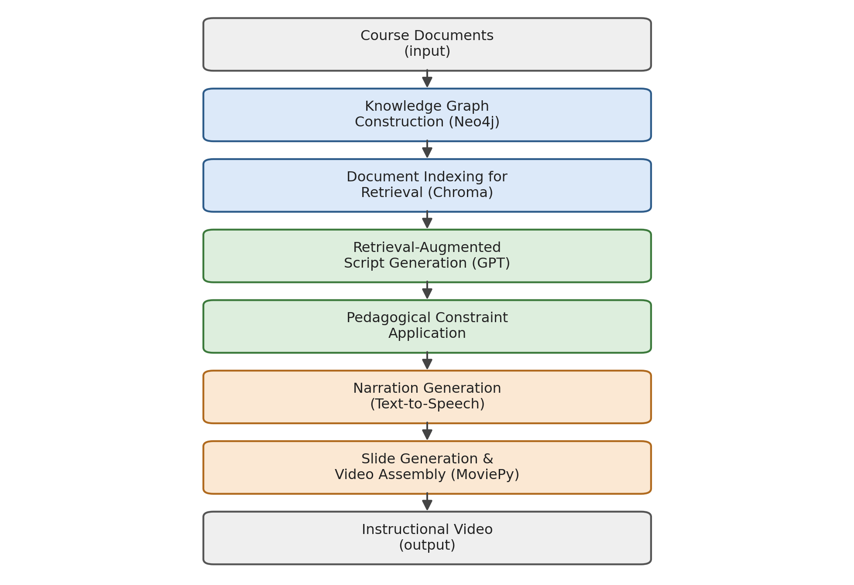
Figure 3.1. System architecture of the AI video generation pipeline
Each stage of the pipeline was implemented as an independent Python module, so that documents could move through the pipeline step by step and any single stage could be modified, re-run, or tested on its own without affecting the others. Section 3.5 describes the implementation of each of these stages in detail.

3.4 Development tools and technologies
Table 3.1 summarises the main tools and technologies used to implement the system.
Table 3.1. Development tools and technologies
Component | Tool / Technology | Purpose
Programming language | Python | Implementation of the entire pipeline
Language model | GPT (OpenAI large language model) | Concept extraction, content generation, and script writing
Knowledge graph storage | Neo4j | Storing extracted concepts and their relationships
Vector database | Chroma | Storing document embeddings for retrieval-augmented generation
Text-to-speech | GPT-based text-to-speech | Converting the generated script into narration audio
Video assembly | MoviePy | Stitching slides and narration into a final video file
Development environment | Standard workstation with internet access | Running the pipeline and connecting to the language model API

3.5 System implementation

3.5.1 Knowledge graph construction
The knowledge graph module accepted the uploaded course documents and passed them to the GPT model with instructions to identify the key concepts discussed in the text and the relationships connecting them, such as prerequisite-of, part-of, or leads-to. The model returned these as concept-relationship-concept triples, which were then written into a Neo4j graph database using the Neo4j Python driver. Listing 3.1 shows a simplified version of this function.
Formally, the extracted concepts and their prerequisite relationships were treated as a directed graph
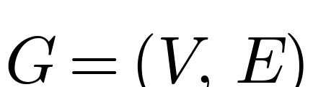 | (3.1)
where V is the set of concepts extracted from the course materials and E ⊆ V × V is the set of prerequisite relationships between them. Because a segment could only be generated for a concept once its prerequisites had been covered, the order in which concepts were presented followed a topological ordering π of G, such that
(3.2)
for every prerequisite edge (a, b) ∈ E. This ordering constraint is what allowed the pedagogical constraint module (Section 3.5.3) to enforce scaffolding, so that a concept was never introduced before the concepts it depended on.
Listing 3.1.: Knowledge graph extraction and storage (simplified)
def extract_knowledge_graph(document_text):
"""Send course text to GPT and return a list of
(concept, relationship, concept) triples."""
prompt = build_extraction_prompt(document_text)
response = call_gpt(prompt)
triples = parse_triples(response)
return triples

def store_triples_in_neo4j(triples, driver):
with driver.session() as session:
for subject, relation, obj in triples:
session.run(
"MERGE (a:Concept {name: $subject}) "
"MERGE (b:Concept {name: $object}) "
"MERGE (a)-[r:RELATION {type: $relation}]->(b)",
subject=subject, object=obj, relation=relation
)

3.5.2 Content indexing and retrieval (RAG)
To reduce the risk of the language model generating inaccurate or fabricated information, commonly referred to as hallucination, the system did not rely solely on the language model's internal knowledge. The uploaded documents were split into smaller text chunks, converted into vector embeddings, and stored in a Chroma vector database. When content needed to be generated for a particular concept, the system retrieved the most relevant chunks from Chroma using similarity search and supplied them to the GPT model as supporting context. Listing 3.2 shows this retrieval step.
Relevance between a query and a stored chunk was measured using cosine similarity between their embedding vectors:
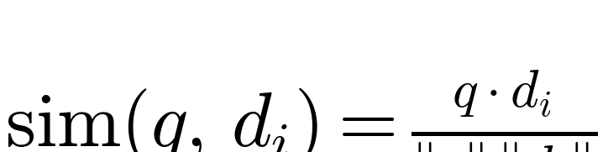 | (3.3)
where q is the embedding of the query and dᵢ is the embedding of a candidate chunk in the Chroma collection D. For each query, the top_k=4 highest-scoring chunks were retrieved and supplied to the language model as supporting context:
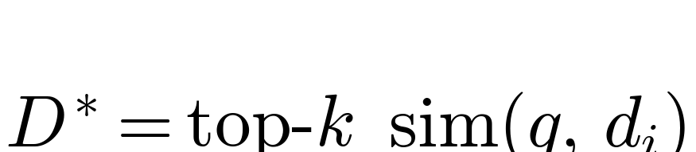 | (3.4)
Restricting generation to this retrieved set, rather than the language model’s unconstrained output.
A second approach was to introduce a relevance-bounded backfil step after the initial top_k retrieval. Let R denote the baseline set of top_k chunks retrieved by equation (3.4), and let S(c) denote the source document of chunk c. For each source document s not represented in R, its best-scoring candidate chunk was identified:

c*ₛ = argmax { sim(q, c) : c ∈ D, S(c) = s } (3.5)

This candidate was admitted into the retrieved set if its score fell within a relaxation margin δ of the weakest chunk currently in R:

sim(q, c*ₛ) ≥ τ − δ, where τ = min{ sim(q, c) : c ∈ R } (3.6)

Rather than fixing δ as a constant, it was defined relative to the score spread already present in R, so that the margin adapts to how decisively the top_k ranking separates one source from another:

δ = α · ( sim(q, c₁) − τ ), 0 < α ≤ 1 (3.7)

where c₁ is the highest-scoring chunk overall. A backfill cap of b_max additional chunks was imposed to bound the size of the final retrieved set, and the retrieved set size was allowed to grow elastically up to k + b_max rather than displacing already-retrieved chunks, so that no chunk scoring above τ was discarded to make room for a lower-scoring one. This preserved the guarantee that generation remained grounded in retrieved evidence the core hallucination-mitigation property described above while extending source coverage where genuinely warranted by relevance.
Listing 3.2.: Document indexing and retrieval for RAG
def index_documents(documents, chroma_collection):
for doc_id, text in enumerate(documents):
chunks = split_into_chunks(text, max_tokens=300)
embeddings = embed_chunks(chunks)
chroma_collection.add(
ids=[f"{doc_id}-{i}" for i in range(len(chunks))],
documents=chunks,
embeddings=embeddings
)

def retrieve_relevant_context(query, chroma_collection, top_k=4):
results = chroma_collection.query(
query_texts=[query],
n_results=top_k
)
return results["documents"][0]

3.5.3 Pedagogical constraint application
The pedagogical constraint module was responsible for shaping the retrieved content into a form that supports learning rather than simply presenting information. The prerequisite ordering obtained from the knowledge graph was used to arrange concepts from simple to complex (scaffolding), each script segment was limited to a small number of new ideas (cognitive load theory), and every segment was required to follow a consistent structure of recap, new concept, example, and check for understanding (instructional sequencing). Listing 3.3 shows how these rules were combined into the prompt used to generate each segment.
Cognitive load theory was operationalised as a hard limit on the number of new concepts Cₛ introduced within a single script segment s:
(3.5)
with N_max set to one in the prompt template shown in Listing 3.3, so that each segment introduced exactly one new concept alongside a recap of the prerequisite concept, an example, and a check for understanding.
Listing 3.3.: Pedagogically constrained prompt template (simplified)
def build_segment_prompt(concept, retrieved_context, previous_concept):
return f"""
Write one short instructional video segment for the concept
below, using ONLY the supporting context provided.

Concept to teach: {concept}
Previously covered concept: {previous_concept}
Supporting context: {retrieved_context}

Follow this structure:
1. Brief recap of "{previous_concept}"
2. Introduce "{concept}" in simple terms
3. Give one short worked example
4. End with a one-line check-for-understanding question

Keep the segment focused on a single new idea only.
"""

3.5.4 Narration generation
Once a segment's script had passed through the pedagogical constraint module, it was sent to a GPT-based text-to-speech process to generate the narration audio for that segment. Listing 3.4 shows this step.
Listing 3.4.: Narration audio generation
def generate_narration(script_segment, output_path):
audio = gpt_text_to_speech(text=script_segment, voice="default")
with open(output_path, "wb") as f:
f.write(audio)
return output_path

3.5.5 Slide generation and video assembly
A slide was generated for each script segment to visually support the narration. MoviePy was then used to combine each slide with its matching narration audio clip, and simple transitions were added between segments, and finally the segments were rendered in sequence into a single instructional video file. Listing 3.5 shows a simplified version of the assembly step.
Listing 3.5.: Slide and narration assembly into a video
from moviepy.editor import ImageClip, AudioFileClip, concatenate_videoclips

def assemble_video(slide_paths, audio_paths, output_path):
clips = []
for slide_path, audio_path in zip(slide_paths, audio_paths):
audio_clip = AudioFileClip(audio_path)
image_clip = ImageClip(slide_path).set_duration(audio_clip.duration)
image_clip = image_clip.set_audio(audio_clip)
clips.append(image_clip)

final_video = concatenate_videoclips(clips, method="compose")
final_video.write_videofile(output_path, fps=24)
return output_path

3.6 Case study: Product Development (Industrial Engineering)
The system was applied to the topic of Product Development, drawn from an Industrial Engineering course, to demonstrate its use on a real subject area. Course materials on this topic were uploaded into the system, which then constructed a knowledge graph, indexed the materials for retrieval, applied the pedagogical constraints, and generated a complete instructional video playlist covering the selected Product Development sub-topics. This subject area was chosen because it contains a sequence of interdependent concepts, making it suitable for testing whether the system's scaffolding and instructional sequencing features worked as intended.

3.7 System testing
Testing of the system took place at two levels: functional testing of the pipeline itself, and a comparative evaluation involving learners. The procedures followed for both are described below; the results obtained are presented in Chapter Four.

3.7.1 Functional testing of the pipeline
Each stage of the pipeline, knowledge graph construction, retrieval, pedagogical constraint application, narration generation, and video assembly, was tested individually using sample course documents before the stages were connected together. This was done to confirm that each stage produced a correctly formatted output that the next stage could accept, for example, that extracted triples were in a form the Neo4j storage function could consume, and that generated scripts were in a form the narration function could accept. The complete pipeline was then tested end-to-end using the Product Development case study, to confirm that a finished video could be produced from uploaded documents without manual intervention between stages.

3.7.2 Evaluation design
To address Objective 5 in Chapter One, the system was evaluated by comparing learner performance after exposure to two versions of instructional content covering the same Product Development sub-topics: the video generated by the proposed system, and an equivalent human-made instructional video.

3.7.3 Participants
Participants were students who had not previously studied the selected Product Development sub-topics in depth. They were divided into two groups: one group watched the AI-generated video, while the other watched the human-made video covering the same content.

3.7.4 Evaluation instrument
A short quiz was administered to both groups immediately after they finished watching their assigned video. The quiz questions were designed to test comprehension and retention of the concepts covered in the video, and the same quiz was given to both groups so that the results could be compared directly.

3.7.5 Data analysis procedure
Quiz scores from the two groups were compared to determine whether there was a meaningful difference in comprehension between learners who watched the AI-generated video and those who watched the human-made video. This comparison was intended to indicate whether the proposed system achieved instructional quality comparable to a human-made video. The results of this comparison are presented and discussed in Chapter Four.
This comparison was carried out using an independent-samples t-test between the mean quiz score of the group that watched the AI-generated video (AI) and the group that watched the human-made video (H):
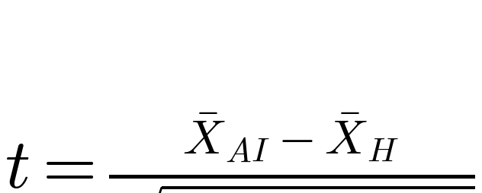 | (3.6)
where X̄_AI and X̄_H are the group mean scores, n_AI and n_H are the group sizes, and sₚ² is the pooled variance of the two groups:
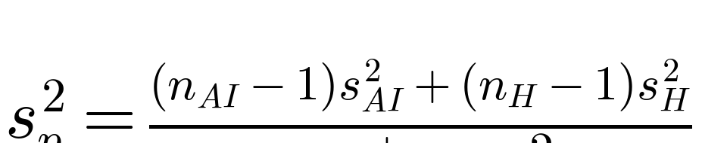 | (3.7)
The magnitude of any difference found was further reported using Cohen’s d effect size:
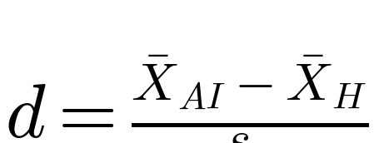 | (3.8)
A significance level of α = 0.05 was adopted, so that a difference between the two groups was considered statistically significant where p < 0.05.

REFERENCES
Hevner, A. R., March, S. T., Park, J. and Ram, S. 2004. Design science in information systems research. MIS Quarterly 28.1:75-105.
Peffers, K., Tuunanen, T., Rothenberger, M. A. and Chatterjee, S. 2007. A design science research methodology for information systems research. Journal of Management Information Systems 24.3:45-77.

